

REACT JS PROJECT REPORT ON
TITLE OF THE PROJECT

Submitted by
NAME: Shri Narayani L
REGISTER NO: 24BIT153

Under the Guidance of
Trainer Name: Aravindh
Technical Trainer
Technical Department, KG College of Arts and Science

Academic Year: 2025 – 2026
APRIL 2026

DECLARATION
I hereby declare that the project entitled “Cab Booking Application” submitted in partial fulfillment of the requirements for the course React JS is a record of my original work carried out under the guidance of Aravindh, Technical Trainer, Technical Department, KG College of Arts and Science.
I further declare that this project has not been submitted previously, either in part or in full, for the award of any degree, diploma, or other similar title, at this or any other institution.
I have acknowledged all sources of information used in this project wherever applicable.

April 2026
Coimbatore

________________________
Shri Narayani L

CERTIFICATE
This is to certify that the project entitled “Cab Booking Application” is a bona fide work carried out by Shri Narayani L [2024 batch], Department of Information Technology, KG College of Arts & Science, in partial fulfillment of the requirements for the course React JS.
This project has been completed under my supervision and guidance during the academic period April 2026.

Place: Coimbatore
Date:16/04/2026

Submitted for the Viva-Voce Examination held on 16/04/2026

Guide: Head of the Department
(Technical Trainer, KGCAS) (Technical Head, KGCAS)

Aravindh Boopalan

TABLE OF CONTENTS
S. No. | Topics | Page. No.
1 | Introduction
1.1 | Background of the Study
1.2 | Problem Statement
1.3 | Objectives of the Project
1.4 | Purpose and Significance
1.5 | Scope and Limitations
1.6 | Methodology Overview
2 | System Analysis
2.1 | Existing System
2.2 | Drawbacks of the Existing System
2.3 | Proposed System
2.4 | Features of the Proposed System
2.5 | Feasibility Study
2.6 | Requirement Analysis
3 | System Design
3.1 | System Architecture
3.2 | Use Case Diagram
3.3 | Data Flow Diagram (DFD)
3.4 | Entity Relationship Diagram (ERD)
3.5 | User Interface Design
4 | System Implementation
4.1 | Development Tools
4.2 | Module Description
4.3 | Algorithms
4.4 | System Integration
4.5 | Security and Validation
5 | System Testing
5.1 | Testing Methodology
5.2 | Test Cases
5.3 | Error Handling
5.4 | Performance
6 | Input and Output Screens
6.1 | System Outputs
6.2 | Discussion
6.3 | Comparison
6.4 | User Feedback
7 | Conclusion and Future Enhancement
7.1 | Summary
7.2 | Limitations
7.3 | Future Scope
8 | References
Appendices
- Source Code Snippets
- Screenshots of Web Pages

ABSTRACT
The Educational Website project is a web-based application designed to provide an interactive platform for online learning. It allows students to access course materials, lessons, and quizzes through an intuitive and responsive interface. The system is developed using React JS and MERN Stack Development, ensuring cross-platform compatibility and ease of use.
The Cab Booking Application is a full-stack web application developed using the MERN stack(MongoDB,Express.js,React.js and Node.js). The system allows users to book rides, track ride status and view booking history through an intuitive interface.
The application includes features such as user authentication, ride booking, fare estimation, driver assignment and ride tracking. React.js is used for building a responsive frontend, while Node.js and Express.js handle backend logic and APIs. MongoDB is used for storing user, ride and driver data securely.
This project aims to simplify urban transportation by providing a seamless digital platform similar to modern ride-hailing services. It demonstrates real-time interaction, RESTful API integration, and secure authentication using JWT

Chapter 1: Introduction
  - Background of the Study
With the growth of urbanization, transportation has become a major challenge.Traditional cab booking methods are inefficient and time-consuming. Modern applications provide instant booking, tracking, and digital payments.
This project leverages MERN stack technologies to create a scalable and efficient cab booking platform.

  - Problem Statement

Existing transportation system suffer from:
- Manual booking delays
- Lack of real-time tracking
- No transparency in pricing
- Poor user experience

1.3 Objectives of the Project
- To develop a cab booking system using MERN stack .
- To implement user authentication using JWT.
- To enable real-time ride booking and tracking.
- To calculate fare dynamically.
- To provide ride history and driver details.

1.4 Purpose and Significance of the Study
The main purpose of this project is to enhance the convenience, reduces waiting time, and enhances user experiences. It demonstrates real-world application of full-stack development

  - Scope and Limitations
Scope:
- Ride booking and tracking.
- User authentication
- Driver assignment
Limitations:
- No real-time GPS integration
- No online payment gateway
- Limited scalability without cloud deployment

1.6 Methodology Overview
The project follows a structured Software Development Life Cycle (SDLC) approach.
  - Requirement analysis
  - System design
  - Development (MERN Stack)
  - Testing
  - Deployment

Chapter 2: System Analysis
2.1 Existing System
- Offline cab booking
- Phone-based taxi services
- No tracking or automation

2.2 Drawbacks of the Existing System
- Time consuming.
- No transparency.
- No ride history.
- No automation.

2.3 Proposed System
The proposed Educational Website provides a centralized, interactive platform where students can browse about pickup and drop location.
- User login/signup
- Ride booking
- Driver assignment
- Fare calculation
- Ride history

2.4 Features of the Proposed System
- JWT Authentication.
- Real-time ride status.
- Multiple ride types(Bike,Auto,Cab).
- Fare estimation.
- Responsive UI.

2.5 Feasibility Study
Technical Feasibility:
The project uses lightweight, open-source technologies —MERN Stack— efficient and scalable development
Economic Feasibility:
Development cost is minimal since it uses free tools and requires no paid hosting or licensed software for the prototype version.
Operational Feasibility:
The system is simple, intuitive, and requires no special training to operate, making it easy for students and educators to adopt.

2.6 Requirement Analysis
Functional Requirements:
- User registration/Logic.
- Book rides.
- View rides.
- Calculate fare.
Non-Functional Requirements:
- Fast loading and efficient performance.
- Secure handling of quiz input and results.
- Accessibility and usability compliance.
- Easy maintenance and scalability for future upgrades.

Chapter 3: System Design
3.1 Introduction
System design defines the overall architecture, structure, and data flow of the project. It translates the requirements gathered during the analysis phase into a blueprint for implementation. For the Cab Booking Application, the design focuses on the interaction between users, web pages, and data components that together deliver course content and quizzes effectively.

3.2 System Architecture
The system follows a three-tier architecture:
- Frontend: React.js
- Backend: Node.js + Express
- Database: MongoDB

3.3 Use Case Diagram
1. What is a Use Case Diagram?
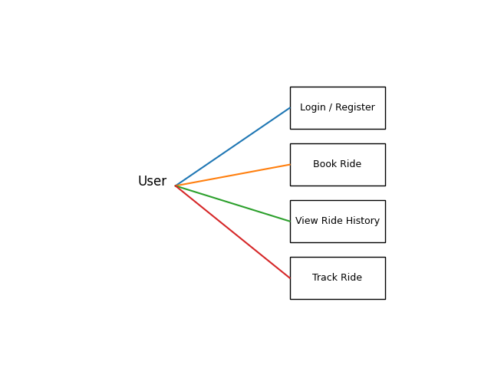
A Use Case Diagram visually helps you explain “Who does what” in your system.

- Data Flow Diagram(DFD):
Level 0:
User → Cab Booking System → Database
Level 1:
- Login Process
- Ride Booking
- Driver Assignment
- Ride Completion

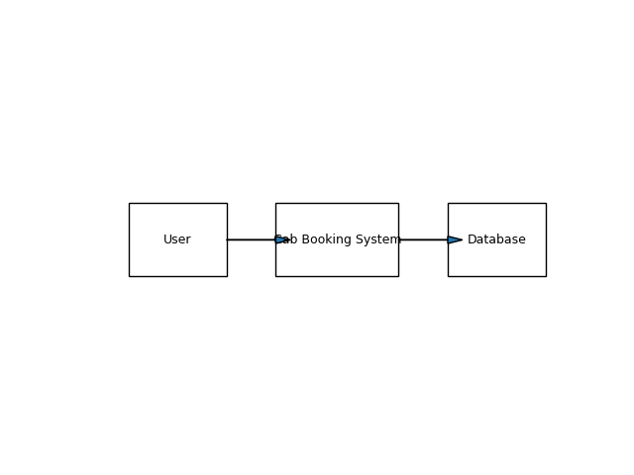

4. Define Relationships
Entities:
- User(userID,name,email,password)
- Ride(rideID,pickup,drop,fare,status)
- Driver(driverID,name,vehicleNo)

5. Draw the Diagram (Structure Example)
Tools you can use:
- draw.io (free online)
- Lucidchart
- StarUML
- MS Visio
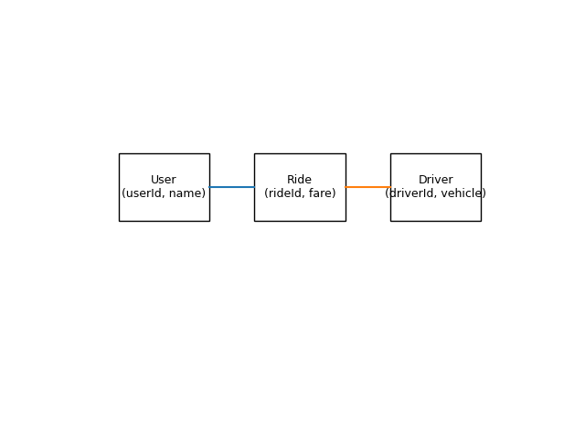

7. Step-by-Step (Using draw.io)
- Go to https://app.diagrams.net
- Choose a blank diagram → name it “Use Case Diagram”.
- From the left panel, drag:
  - Stick figures → represent Actors.
  - Ovals → represent Use Cases.
  - Box → system boundary (“Educational Website”).
- Connect Actors ↔ Use Cases using lines.
- Label relationships (<<include>> / <<extend>>).
- Export as .PNG / .JPG and insert into your documentation.
Chapter 4: System Implementation
4.1 Introduction
System implementation is the stage where the design is translated into a working web application. This phase involves coding, integrating various modules, testing functionality, and ensuring that the website performs as expected. The Cab Booking Application is implemented using front-end technologies React JS and MERN stack to provide an interactive and responsive learning platform.

4.2 Development Tools and Technologies
Tool / Technology | Purpose
React JS | Frontend UI
Node.js | Backend runtime.
Express.js | API handling
MongoDB | Database
Browser (Chrome / Edge) | Used for execution and debugging of the web application.
Visual Studio Code | Code editor for development and testing.

4.3 System Modules Description
Module
Authentication Module
Ride booking Module
Driver Module
Fare calculation Module
Ride history Module

4.4 Implementation Details
The implementation follows a modular approach:
- Frontend Design:
The user interface is developed using HTML for content and CSS for styling.
- Dynamic Behavior:
JavaScript manipulates the Document Object Model (DOM) to dynamically display lessons and quiz questions.
- Event Handling:
Buttons and inputs are linked to event listeners (e.g., onclick, onsubmit) to handle user actions.
- Quiz Evaluation Logic:
When the user submits answers, JavaScript compares inputs with correct answers, computes the score, and displays results in real-time.
- Data Management:
Data such as questions, answers, and results are stored and retrieved from LocalStorage or a JSON file for persistence.

4.5 Algorithm / Logic of Core Function
Algorithm for Fare calculation :
  - Input distance
  - Multiply by rate
  - Add base fare
Algorithm for Ride booking:
- User selects pickup & drop.
- System calculate fare
- Driver assigned
- Ride confirmed

4.6 Security and Validation:
- JWT authentication.
- Input validation.
- Protected one.

4.7 Integration
All modules are seamlessly integrated using event-driven programming. Frontend communicates with backend APIs using Axios.

Chapter 5: System Testing
5.1 Introduction
System testing is a crucial phase that ensures the developed application meets all functional and non-functional requirements. It validates whether the system performs as expected under various conditions. For the Cab Booking Application, testing was conducted to verify the functionality of modules, including course display, lesson navigation, quiz evaluation, and result generation.

5.2 Test Cases:
Test ID | Module | Expected Result
T01 | Login | Successful login
T02 | Booking | Ride created
T03 | Fare | Correct calculation
T04 | History | Display rides

5.3 Types of Testing Performed
a) Unit Testing
Each JavaScript function and webpage component was tested independently. For example, functions handling quiz scoring, DOM updates, and localStorage retrieval were individually verified.
b) Integration Testing
After unit testing, all modules were combined and tested as a whole to ensure that navigation between pages worked without errors.
c) System Testing
The complete web application was tested to ensure all functional requirements were met — including quiz evaluations, course listings, and responsiveness.
d) User Acceptance Testing (UAT)
The system was demonstrated to sample users to gather feedback. The website’s layout, speed, and usability were reviewed, and suggestions were implemented where necessary.
e) Cross-Browser and Device Testing
The system was tested on popular browsers such as Google Chrome, Mozilla Firefox, and Microsoft Edge, and on devices like laptops, tablets, and mobile phones to ensure responsiveness.

5.6 Error Handling
- Invalid login alerts
- API error handling.
- Input validation.

5.7 Performance and Usability Testing
- Performance: Page load time was under 2 seconds in standard browsers.
- Usability: Students found the website easy to navigate, visually clear, and responsive.
- Accessibility: The system supports keyboard navigation and uses readable font styles for better visibility.

5.8 Results and Observations
All modules functioned as expected. The website performed well on multiple devices, and user feedback confirmed that it was interactive and efficient. No critical defects were identified in the final round of testing.

Chapter 6: Results and Discussion
6.1 Introduction
This chapter presents the practical results obtained after implementation and testing. It demonstrates how each module of the Cab booking application performed during execution and how well the system met its stated objectives.

6.2 System Outputs
During execution, the system produced the following key results:
- Homepage: Displaying successful login with short descriptions.
- Ride booking successful
- Fare calculation
- Driver assigned
- Ride history shown

6.3 Performance Analysis
- Responsiveness: Average page load time < 2 seconds.
- Accuracy: fare calculation achieved 100 % logical accuracy.
- Stability: No runtime or data-handling errors during repeated trials.
- Cross-Browser Compatibility: Verified on Chrome, Edge, and Firefox with consistent results.

6.4 User Feedback
A small group of student users tested the prototype. Feedback indicated:
- Simple and intuitive navigation.
- Readable layout and clear quiz interface.
- Desire for additional courses and login functionality in future versions.

Chapter 7: Conclusion and Future Enhancement
7.1 Conclusion
The Cab Booking Application project successfully demonstrates how modern web technologies can be applied to create an interactive and accessible learning platform. By utilizing MERN stack development the system offers a responsive interface that enables users to book rides, know the time taken, status of the booking and live location .
The project achieved its primary objectives of delivering a simple, user-friendly, and dynamic web application . Testing confirmed that all modules operate efficiently and reliably. The system meets functional and non-functional requirements such as usability, portability, and responsiveness.
This work highlights how front-end web development can support the goals of cab booking by combining functionality, design, and accessibility. It also serves as a strong foundation for future expansion into a complete online cab booking management system.

7.2 Limitations
While the system meets its core goals, the current version has a few limitations:
- No GPS tracking.
- No payment integration.

7.3 Future Enhancement
The project can be enhanced and scaled in several ways:
- Google maps integration
- Online payment
- Live tracking
- Mobile app version

Chapter 8: References
  - MDN web docs
  - MongoDB documentation
  - React Documentation
  - Node.js documentation

8.3 Tools & Frameworks Used
- Editor: Visual Studio Code
- Languages: HTML5, CSS3, JavaScript (ES6)
- Framework: Bootstrap 5 (for responsive UI)
- Database (Future Scope): JSON / MySQL
- Browser: Google Chrome / Microsoft Edge

Appendices
Appendix A – Source Code
Include your main source files:
- Client/ - frontend developments
- Server/ - backend development
- Models/ - mongoDB connection
(Attach or paste formatted source code snippets here — only essential parts, not full-length code, to maintain report readability.)
Appendix B – Screenshots of Web Pages
Attach labeled screenshots with captions:
- Figure 1.1: Login page.
- Figure 1.2: Pickup drop user prompt.
- Figure 1.3:Estimated distance,calculation.
- Figure 1.4:Driver assignment / ride status.
- Figure 1.5: Map view of the location.
(Ensure all figures are captioned and referenced in your text, e.g., “Refer to Figure 1.3”).
Appendix C – User Manual / Installation Guide
Steps to Run the Project:
- Download all project files .
- Place them in the same folder.
- Open the links given in the terminal in any modern browser (Chrome, Firefox, Edge).
- Browse the required pickup drop location,check status of the ride.
- Check your result displayed instantly on the page.
System Requirements:
- OS: Windows / macOS / Linux
- Browser: Latest Chrome or Firefox
- RAM: Minimum 2 GB
- Storage: 100 MB free

